1. Chapter Title (TimesNewRoman, 12pt, bold)
The Body Text (TimesNewRoman, 10.5pt, Standard) the body text Footnote the body text the body text the body text the body text the body text the body text the body text the body text the body text the body text the body text the body text the body text, the body text the body text ; the body text the body text the body text the body text the body text : the body text.
The Body Text (TimesNewRoman,10.5pt,Standard)the body text the body text the body text the body text the body text the body text the body text the body text the body text the body text the body text the body text the body text the body text, the body text the body text ; the body text the body text the body text the body text the body text : the body text. The Body Text the body text the body text the body text the body text the body text the body text the body text the body text the body text the body text the body text the body text the body text the body text, the body text the body text ; the body text the body text the body text the body text the body text : the body text.
Please delete these textboxes when you edit this file.
In order to unify the style, please set the font style and font size of the described in these pages.
The Body Text the body text the body text the body text the body text the body text the body text the body text the body text the body text the body text the body sentence text the body text the body text the body text, the body text the body text ; the body text the body text the body text the body text the body text : the body text.

1.1:Section Title (TimesNewRoman, 11pt,Bold)
The Body Text (TimesNewRoman, 10.5pt, Standard) the body text Footnote the body text the body text the body text the body text the body text the body text the body text the body text the body text the body text the body text the body text the body text, the body text the body text ; the body text the body text the body text the body text the body text : the body text. The Body Text the body text the body text the body text the body text the body text the body text the body text the body text the body text the body text the body text the body text the body text the body text, the body text the body text ; the body text the body text the body text the body text the body text : the body text.
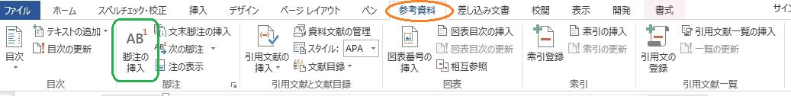
(1)Table/Figure notes set under the Table (Arial, 9pt, standard)
(2)Table/Figure notes set under the Table (Arial, 9pt, standard)
Fig.1：Figure Title (Arial, 10pt, Standard, Centre, set under the figure)

The Body Text the body text the body text the body text the body text the body text the body text the body text.
The Body Text the body text the body text the body text the body text the body text the body text the body text the body text the body text the body text the body text the body text the body text the body text, the body text the body text ; the body text the body text the body text the body text the body text : the body text. The Body Text the body text the body text the body text the body text the body text the body text the body text the body text the body text the body text the body text the body text the body text the body text, the body text the body text ; the body text the body text the body text the body text the body text : the body text.
The Body Text the body text the body text the body text the body text the body text the body text the body text the body text the body text the body text the body text the body text the body text the body text, the body text the body text ; the body text the body text the body text the body text the body text : the body text.
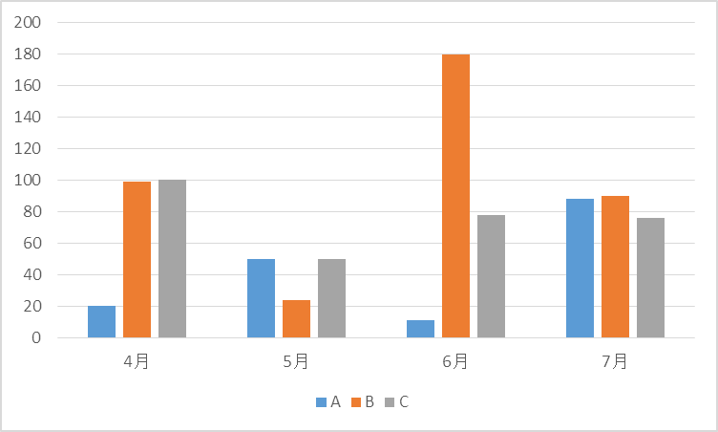
(Note1) Table/Figure notes set under the Table (Arial, 9pt, standard)
Fig.2:Graph Title(Arial, 10pt, Standard, Center, set under the Figure)

The Body Text the body text the body text the body text the body text the body text the body text the body text the body text the body text the body text the body text the body text the body text the body text, the body text the body text ; the body text the body text the body text the body text the body text : the body text.
Please delete these textboxes when you edit this file.
The chart must be paste as the image data. Never insert the Excel Book.
No titles in the chart or figure. Put the Title under the chart or figure as the text line.
Chart or figure notes must put under the data, before the title.
The Body Text the body text the body text the body text the body text the body text the body text the body text the body text the body text the body text the body text the body text the body text the body text, the body text the body text ; the body text the body text the body text the body text the body text : the body text.

2.2:Section Title (TimesNewRoman, 11pt, Bold)
The Body Text (TimesNewRoman, 10.5pt, Standard) the body text the body text the body text the body text the body text the body text the body text the body text the body text the body text the body text the body text the body text the body text, the body text the body text ; the body text the body text the body text the body text the body text : the body text. The Body
Table 1: Title of Table (Arial, 10pt, Centre, set before the table)
分類 | A | B | C
Apr. | 20 | 99 | 100
May | 50 | 24 | 50
June | 11 | 180 | 78
July | 88 | 90 | 76
(Note1) Footnote of the table. Set under the table(Arial 9pt, line-space 9pt, prior to paragraph 2pt)
(Note2) Footnote of the table. Set under the table(Arial 9pt, line-space 9pt, prior to paragraph 2pt)
The table : never embed the Excel Book.
Put the image data of the table, with no titles in it . Put the Table Title before the Table as the text line. Table note must be put under the Table.
Text the body text the body text the body text the body text the body text the body text the body text the body text the body text the body text the body text the body text the body text the body text, the body text the body text ; the body text the body text the body text the body text the body text : the body text. The Body Text the body text the body text the body text the body text the body text the body text the body text the body text the body text the body text the body text the body text the body text the body text, the body text the body text ; the body text the body text the body text the body text the body text : the body text.

The Body Text the body text the body text the body text the body text the body text the body text the body text the body text the body text the body text the body text the body text the body text the body text, the body text the body text ; the body text the body text the body text the body text the body text : the body text. The Body Text the body text the body text the body text the body text the body text the body text the body text the body text the body text the body text the body text the body text the body text the body text, the body text the body text ; the body text the body text the body text Footnote the body text the body text : the body text.
The Body Text the body text the body text the body text the body text the body text the body text the body text the body text the body text the body text the body text the body text the body text the body text, the body text the body text ; the body text the body text the body text the body text the body text : the body text. The Body Text the body text the body text the body text the body text the body text the body text the body text the body text the body text the body text the body text the body text the body text the body text, the body text the body text ; the body text the body text the body text the body text the body text : the body text.
The Body Text the body text the body text the body text the body text the body text the body text the body text the body text the body text the body text the body Footnote text the body text the body text the body text, the body text the body text ; the body text the body text the body text the body text the body text : the body text.

3. Chapter Title (TimesNewRoman, 12pt,bold)
The Body Text the body text the body text the body text the body text the body text the body text the body text the body text the body text the body text the body text the body text the body text the body text, the body text the body text ; the body text the body text the body text Footnote the body text the body text : the body text. The Body Text the body text the body text the body text the body text the body text the body text the body text the body text the body text the body text the body text the body text the body text the body text, the body text the body text ; the body text the body text the body text the body text the body text : the body text. The Body Text the body text the body text the body text the body text the body text the body text the body text the body text the body text the body text the body text the body text the body text Footnote the body text, the body text the body text Footnote ; the body text the body text the body text the body text the body text : the body text.
The Body Text the body text the body text the body text the body text the body text the body text the body text the body text the body text the body text the body text the body text the body text the body text, the body text the body text ; the body text the body text the body text the body text the body text : the body text.
The Body Text the body text the body text the body text the body text the body text the body text the body text the body text the body text the body text the body text the body text the body text the body text, the body text the body text ; the body text the body text the body text the body text the body text : the body text.
The Body Text the body text the body text the body text the body text the body text the body text the body text the body text the body text Footnote the body text the body text the body text the body text the body text, the body text the body text ; the body text the body text the body text the body text the body text : the body text.
The Body Text the body text the body text the body text the body text the body text the body text the body text the body text the body text the body text the body text the body text the body text the body text, the body text the body text ; the body text the body text the body text the body text the body text : the body text.

The Body Text the body text the body text the body text the body text the body text the body text the body text the body text the body text the body text the body text the body text the body text the body text, the body text the body text ; the body text the body text the body text the body text the body text : the body text. Footnote The Body Text the body text the body text the body text the body text the body text the body text the body text the body text the body text the body text the body text the body text the body text the body text, the body text the body text ; the body text the body text the body text the body text the body text : the body text.

Reference or Appendix (TimesNewRoman, 11pt,Bold)
Author Name. (20●●) Book Title(Italic), Date of publication, The publisher.
Reference (TimesNewRoman, 10pt standard ) reference, reference reference reference reference
(after second line: 2 leters indent) reference reference reference 123456
Reference (TimesNewRoman, 10pt standard ) reference, reference reference reference reference
(after second line: 2 leters indent) reference reference reference 123456
Reference (TimesNewRoman, 10pt standard ) reference, reference reference reference reference
(after second line: 2 leters indent) reference reference reference 123456
Reference (TimesNewRoman, 10pt standard ) reference, reference reference reference reference
(after second line: 2 leters indent) reference reference reference 123456
Reference (TimesNewRoman, 10pt standard ) reference, reference reference reference reference
(after second line: 2 leters indent) reference reference reference 123456
Reference (TimesNewRoman, 10pt standard ) reference, reference reference reference reference
(after second line: 2 leters indent) reference reference reference 123456
Reference (TimesNewRoman, 10pt standard ) reference, reference reference reference reference
(after second line: 2 leters indent) reference reference reference 123456

Footnote sentence (TimesNewRoman, 8pt,standard,) footnote sentence footnote sentence footnote sentence footnote sentence footnote sentence footnote sentence footnote sentence footnote sentence footnote sentence
Footnote sentence (TimesNewRoman, 8pt,standard,) footnote sentence footnote sentence footnote sentence footnote sentence footnote sentence footnote sentence footnote sentence footnote sentence footnote sentence
Footnote sentence (TimesNewRoman, 8pt,standard,) footnote sentence footnote sentence footnote sentence footnote sentence footnote sentence footnote sentence footnote sentence footnote sentence footnote sentence
Footnote sentence (TimesNewRoman, 8pt,standard,) footnote sentence footnote sentence footnote sentence footnote sentence footnote sentence footnote sentence footnote sentence footnote sentence footnote sentence
Footnote sentence (TimesNewRoman, 8pt,standard,) footnote sentence footnote sentence footnote sentence footnote sentence footnote sentence footnote sentence footnote sentence footnote sentence footnote sentence
Footnote sentence (TimesNewRoman, 8pt,standard,) footnote sentence footnote sentence footnote sentence footnote sentence footnote sentence footnote sentence footnote sentence footnote sentence footnote sentence
Footnote sentence (TimesNewRoman, 8pt,standard,) footnote sentence footnote sentence footnote sentence footnote sentence footnote sentence footnote sentence footnote sentence footnote sentence footnote sentence
Footnote sentence (TimesNewRoman, 8pt,standard,) footnote sentence footnote sentence footnote sentence footnote sentence footnote sentence footnote sentence footnote sentence footnote sentence footnote sentence
Footnote sentence (TimesNewRoman, 8pt,standard,) footnote sentence footnote sentence footnote sentence footnote sentence footnote sentence footnote sentence footnote sentence footnote sentence footnote sentence

